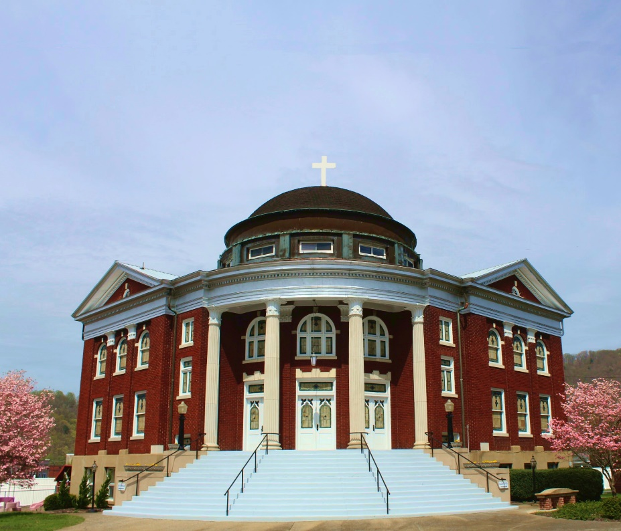

Erwin Presbyterian Church
Palm Sunday * March 24, 2024 * 11:00 a.m.
105 N. Elm Ave., Erwin, TN 37650 *423-743-3431*
erwinpresbyterianchurch.com

Prelude The Palms arr. Jean Baptiste Faure
Ethan Thomas, organist

Welcome and Announcements The Rev. Dr. Ramy Marcos

Introit Hosanna, Loud Hosanna Red Hymnbook #185

* Call to Worship Mike Reese
Leader: With crowds from ancient times we cry,
All: Hosanna! Save us!
Leader: give thanks to the Lord, for God is good!
All: God’s steadfast love endures forever.
Leader: Blessed is the one who comes in the name of the Lord!
All: We bless you in the house of the Lord!
Leader: Lo, your king comes to you; triumphant and victorious is he,
All: Humble and riding on a donkey, on a colt, the foal of a donkey.
Leader: Let us worship the living God!

*Hymn Now Thank We All Our God Red Hymnbook, #9

Call to Confession Mike Reese
Leader: Let us now confess before God our tendency, like the Jerusalem crowds, to profess our faith in moments of enthusiasm and deny our faith in moments of fear and stress.

Prayer of Confession Mike Reese
All: Merciful God, as we enter this Holy Week of Lent, solemnly gathered at your house of prayer, we turn our hearts toward Jerusalem. We want to walk the way with Jesus, to be present each step from the Mount of Olives to the cross to the empty tomb. And yet we fall away. Forgive our stubborn resistance to Christ’s work and witness. Inspire us by your Spirit to follow in his way, until we enter with him into the city not made by human hands, the new Jerusalem, eternal in the heavens. May your will be done on earth as it is in heaven.

(Please take a moment of silent confession)
Assurance of Pardon Mike Reese
Leader: The one who rode into Jerusalem to cheering crowds knew that the cross awaited. In this way, we might know the great love of God for us. Jesus Christ, risen from the dead, has defeated sin forever. Hear and believe this good news! In Jesus Christ, we are forgiven!

All: Thanks be to God.

*Gloria Patri Red Hymnbook, #546

Glory be to the Father, and to the Son, and to the
Holy Ghost; As it was in the beginning, is now, and
ever shall be, world without end. Amen, Amen.

*The Peace The Rev. Dr. Ramy Marcos
Pastor: Jesus said, “My peace I give to you. Do not let your hearts be troubled and do not let them be afraid.” May the peace of our Lord Jesus Christ be with you all.
All: And also with you.
Pastor: Please take a moment to greet one another and share the peace of Christ.

First Scripture Reading-Zachariah 9:9-13 Mike Reese
⁹ Rejoice greatly, Daughter Zion! Shout, Daughter Jerusalem! See, your king comes to you, righteous and victorious, lowly and riding on a donkey, on a colt, the foal of a donkey. ¹⁰ I will take away the chariots from Ephraim and the warhorses from Jerusalem, and the battle bow will be broken. He will proclaim peace to the nations. His rule will extend from sea to sea and from the River to the ends of the earth. ¹¹ As for you, because of the blood of my covenant with you, I will free your prisoners from the waterless pit. ¹² Return to your fortress, you prisoners of hope; even now I announce that I will restore twice as much to you. ¹³ I will bend Judah as I bend my bow and fill it with Ephraim. I will rouse your sons, Zion, against your sons, Greece, and make you like a warrior’s sword.

Leader: This is the Word of the Lord All: Thanks be to God

Anthem Of Palms and Praise
Prayer for Illumination The Rev. Dr. Ramy Marcos
Second Scripture Reading- John 12:12-19 The Rev. Dr. Ramy Marcos
¹² The next day the great crowd that had come for the festival heard that Jesus was on his way to Jerusalem. ¹³ They took palm branches and went out to meet him, shouting, “Hosanna!” “Blessed is he who comes in the name of the Lord!” “Blessed is the king of Israel!” ¹⁴ Jesus found a young donkey and sat on it, as it is written: ¹⁵ “Do not be afraid, Daughter Zion; see, your king is coming, seated on a donkey’s colt.”
¹⁶ At first his disciples did not understand all this. Only after Jesus was glorified did they realize that these things had been written about him and that these things had been done to him.
¹⁷ Now the crowd that was with him when he called Lazarus from the tomb and raised him from the dead continued to spread the word. ¹⁸ Many people, because they had heard that he had performed this sign, went out to meet him. ¹⁹ So the Pharisees said to one another, “See, this is getting us nowhere. Look how the whole world has gone after him!”

Leader: This is the Word of the Lord All: Thanks be to God

Sermon Jesus’s Parade The Rev. Dr. Ramy Marcos

Introduction

First, The King

Second, The Lamb

Conclusion

*Declaration of Faith (The Nicene Creed) Mike Reese
Leader: Let’s declare our faith.
All: We believe in one God, the Father, the Almighty, maker of heaven and earth, of all that is, seen and unseen.

We believe in one Lord, Jesus Christ, the only Son of God, eternally begotten of the Father, God from God, Light from Light, true God from true God, begotten, not made, of one Being with the Father; through him all things were made.
For us and for our salvation he came down from heaven, was incarnate of the Holy Spirit and the Virgin Mary and became truly human. For our sake he was crucified under Pontius Pilate; he suffered death and was buried. On the third day he rose again in accordance with the Scriptures; he ascended into heaven and is seated at the right hand of the Father. He will come again in glory to judge the living and the dead, and his kingdom will have no end.

We believe in the Holy Spirit, the Lord, the giver of life, who proceeds from the Father and the Son, who with the Father and the Son is worshiped and glorified, who has spoken through the prophets. We believe in one holy catholic and apostolic Church. We acknowledge one baptism for the forgiveness of sins. We look for the resurrection of the dead, and the life of the world to come. Amen.

Prayer of the People The Rev. Dr. Ramy Marcos
Ends with The Lord’s Prayer
All: Our Father, who art in heaven, hallowed be thy name. Thy kingdom come, thy will be done, on earth as it is in heaven. Give us this day our daily bread; and forgive us our debts, as we forgive our debtors; and lead us not into temptation, but deliver us from evil. For thine is the kingdom, and the power, and the glory, forever. Amen.

Offering
Invitation to the Offering Mike Reese
Leader: Consider what you carry in your hands today. Do you carry the rein of a donkey, a cloak to share, a branch to wave? What do you bring to welcome the Lord today? Whether you share your gifts today as the plates are passed or through the mail, trust that the Lord needs you.

(may the ushers move forward and collect the offering)
Offertory Music Ride On! Ride On in Majesty!
*Doxology Praise God, from Whom All Blessings Flow Red Hymnbook, #544

Praise God, from whom all blessings flow;
Praise God all creatures here below;
Praise God above, ye heavenly host;
Creator, Christ, and Holy Ghost. Amen

*Prayer of Dedication Mike Reese
Leader: As the crowds cried, “Blessed is the one who comes in the name of the Lord,” we are truly grateful for the greatest gift of all, Jesus Christ our Lord. Receive these gifts as a symbol of the dedication of our very selves to you, O God. Use our gifts and use us as a part of inclusion in your kingdom, which comes and is still coming into our world today.
All: Amen.

*Hymn All Glory, Laud, and Honor Red Hymnal #187

*Benediction The Rev. Dr. Ramy Marcos

*Benediction Response Take My Life and Let It Be

Take my life and let it be
Consecrated, Lord, to Thee.
Take my moments and my days.
Let them flow in ceaseless praise.
Let them flow in ceaseless praise.

Postlude “Toccata” from the Fifth Organ Symphony arr. Charles-Marie Widor
Ethan Thomas, organist

Notes:
*Responses with an asterisk indicate standing. Please stand as you are able.
Sources for Worship Liturgy: The liturgy is based on The Presbyterian Outlook.

Announcements:

Youth Lenten Study (Sundays at 10 a.m., until March 31) In the Scout Hall.

Easter Lilies and the Helping Fund – You may purchase Easter Lilies to be placed in the sanctuary, honoring or memorializing a loved one. The deadline to purchase is March 24. Order forms may be found in the narthex. Pick up of ordered lilies will be March 31.

Maundy Thursday (Thursday, March 28 at 7 p.m.)

Philippians Bible Study (Wednesday, April 10, 17, and 24 at 6 p.m.) Please join us for this three-week bible study on Philippians.

Piano Concert (Sunday, April 14 at 2 p.m.) Join us for a Magical Hour of Classical Piano Music by Jeremi Lukanus.

Mission Trip – Urban mission work in Washington, DC, for ages 13 and older, June 12 to June 16. The cost is $50 and payment is due April 15, 2024. Please contact Nic Chambers or Sarah Shults for details.

Session Meeting (Tuesday, April 9 at 6 p.m.)

Food Collection – The food pantry item for March is canned fruit.

Elder of the Month – Betty Stevens

Welcome Visitors: Welcome! If you are visiting, please fill out one of the green visitor’s cards from the pew and put it in the offering plate. We are glad you are here! Hope to see you again soon!

Contact Information:

Pastor: Rev. Dr. Ramy N. Marcos Administrative Assistant: Jackie Andrews
Email: ramynmarcos@gmail.com Email: ErwinPresChurch@gmail.com
Phone: 860-322-7683 Phone: 423-743-3431 (office)
Office hours: M-Th, Sun: 8 a.m.- 4 p.m. Office hours: Mon-Th: 9 a.m. - 2 p.m.

